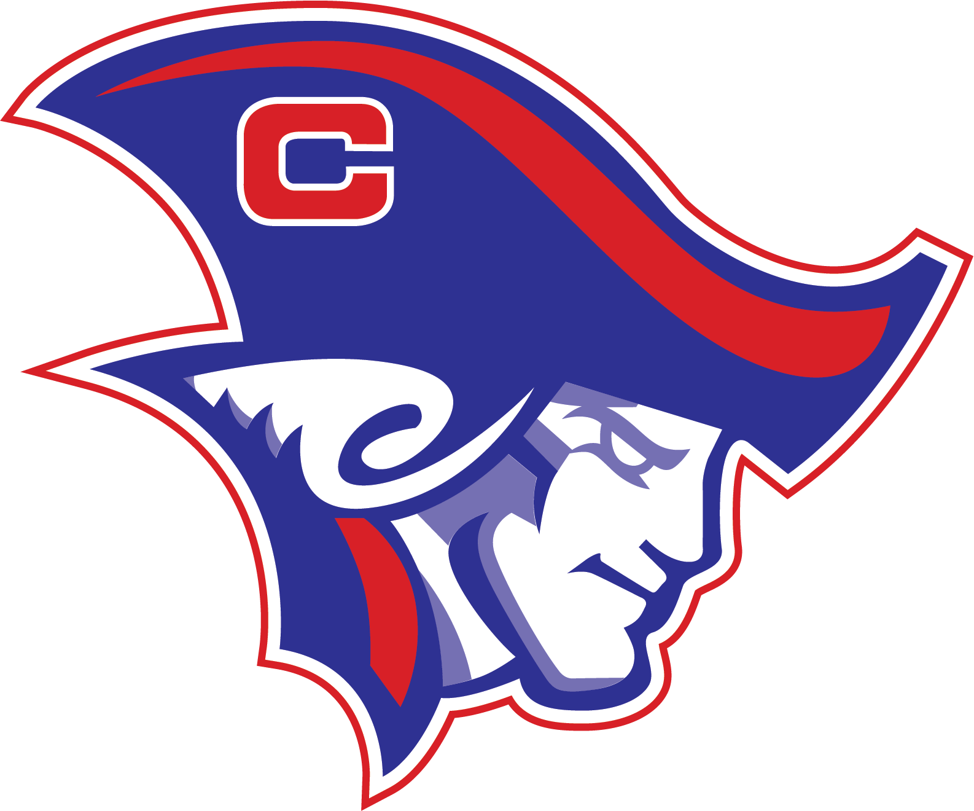 Clarkson Public School

Performance Action Plan

Goal #1: All classes will increase reading proficiency, with an emphasis on comprehension, across all content areas.
School Improvement Smart Goal #1:
By Spring 2025, all classes will show growth in MAP Reading for grades K-10.
Support Data
- MAP: K-10th Grade Fall/Winter

Objectives: The school will utilize data from sources including Fastbridge to develop MTSS and CTE student supports, revise Title 1 interventions, and establish SOC compliance measures.

Curriculum: McGraw Hill Wonders, Heinemann Expressions, SAVVAS Reading & Math, Mystery Science, DiscoveryEd, Science Fusion, CTE varies by standards

Teachers: K-12 teachers utilize data to determine student growth, which allows teachers to reflect on instructional practices.

Classroom: All classrooms will focus on direct instruction using the Marzano vocabulary routine(Explain, Restate, Show, Discuss, Refine & Reflect, and Apply in Learning).

Learners: All classes will show improvement on MAP data in the areas of comprehension and vocabulary.
All 4-6th grade students participate in intervention or enrichment during Patriot Enrichment Period every day, depending on their individual learning needs.
7-12th grade students who are failing any classes must participate in daily Patriot Period interventions.

Goal #2: All classes will increase academic vocabulary in all content areas.
School Improvement Smart Goal #2:
By Spring 2025, all classes will show annual growth in content vocabulary for grades K-10.
Support Data
- Vocabulary Pre/Post Test
Objectives: Teachers will implement pre-tests and post-tests for data collection and use explicit instruction of guaranteed vocabulary.

Curriculum: McGraw Hill Wonders, Heinemann Expressions, SAVVAS Reading & Math, Mystery Science, DiscoveryEd, Science Fusion, CTE varies by standards

Teachers: K-12 teachers determine their classroom guaranteed vocabulary based upon subject area standards. Each teacher is responsible for conducting a pre-test and post-test at the end of the course or year with each of their students. Teachers utilize data to determine student growth, which allows teachers to reflect on instructional practices.

Classroom: All classrooms will focus on direct instruction using the Marzano vocabulary routine(Explain, Restate, Show, Discuss, Refine & Reflect, and Apply in Learning).

Learners: All classes will show improvement on guaranteed vocabulary pre- and post-testing data.
-All 4-6 grade students participate in intervention or enrichment during Patriot Enrichment Period every day, depending on their individual learning needs.
-7-12 grade students who are failing any classes must participate in daily Patriot Period interventions.

Goal #3: To advance communication and engagement with all stakeholders to foster the development of Clarkson Public School’s students.
School Improvement Smart Goal #3:
By Spring 2025, the district will increase interactions with patrons through multiple forms of communication.

Support Data
- Strategic Planning data
- Clarkson Public Schools Facebook data dashboard
- School website traffic data
- Frequency of posts on school social media accounts

Objectives: Improve transparency and communication between the school board, administration, staff, and stakeholders.

To consistently update social media platforms with school events.
Website Improvements: Regularly update the school website with news, events, and photographs.
JMC Alerts: Use automated messaging systems for important reminders and emergency updates.
Staff & Student Spotlights: Highlight the achievements of teachers and students

Stakeholders: Multiple platforms to access information
Facebook
Instagram
X
School Website
Remind
Class Dojo
Colfax County Press
The Red Review: Monthly Newsletter

